|  |  |  |
| --- | --- | --- |
| Nama | : | Rasyid Ibrahim Fattah |
| Kode Peserta | : | FSDO001ONL030 |

**ASSIGNMENT 2**

---------------------------------------------------------------

1. Customers => stores data customer

--------------------------------------------------------------

create table tbl_customers(

    customerNumber int identity(1,1) primary key,

    customerName varchar(50),

    contactFirstName varchar(50),

    contactLastName varchar(50),

    phone varchar(13) unique,

    addressLine1 varchar(100),

    addressLine2 varchar(100),

    city varchar(50),

    state varchar(50),

    postalCode int,

    salesRepEmployeeNumber int,

    creditLimit int

);

insert into tbl_customers(customerName, contactFirstName, contactLastName, phone, addressLine1, addressLine2, city,

state, postalCode, salesRepEmployeeNumber, creditLimit)values

('Adi Putro', 'Adi', 'Putro', '086435978465', 'Jl. flamboyan', '', 'Semarang', 'Indonesia', '65485', '2', '10000000'),

('Baim Paula', 'Baim', 'Paula', '089784684625', 'Jl. flores', '', 'Brebes', 'Indonesia', '65985', '2', '10000000'),

('Ronaldo', 'Ronaldo', '', '086452194532', 'Jl. Merpati', '', 'Jakarta', 'Indonesia', '36521', '1', '25000000'),

('Mawar Melati Indah', 'Mawar', 'Melati Indah', '085556425495', 'Jl. Supratman', 'RT 01/03', 'Semarang', 'Indonesia', '65874', '3', '10000000'),

('Rafi Ahmad Dani', 'Rafi', 'Ahmad Dani', '08644135644', 'Jl. Katak', '', 'Surabaya', 'Indonesia', '33656', '2', '15000000'),

('Lestari Ningrum', 'Lestari', 'Ningrum', '088895741652', 'Jl. Sukajaya', '', 'Medan', 'Indonesia', '65485', '1', '10000000'),

('Nur Cahyono Putra', 'Nur', 'Cahyono Putra', '089999657416', 'Jl. Mangga', '', 'Brebes', 'Indonesia', '65985', '2', '10000000'),

('Dimas Anggara', 'Dimas', 'Anggara', '086555964313', 'Jl. Merpati', '', 'Malang', 'Indonesia', '36521', '1', '25000000'),

('Teguh', 'Teguh', '', '086455213649', 'Jl. Harjosari', 'RT 01/03', 'Semarang', 'Indonesia', '65874', '3', '10000000'),

('Fadil Pradiansyah', 'Fadil', 'Pradiansyah', '087779467134', 'Jl. Merpati', '', 'Tegal', 'Indonesia', '33656', '3', '15000000');

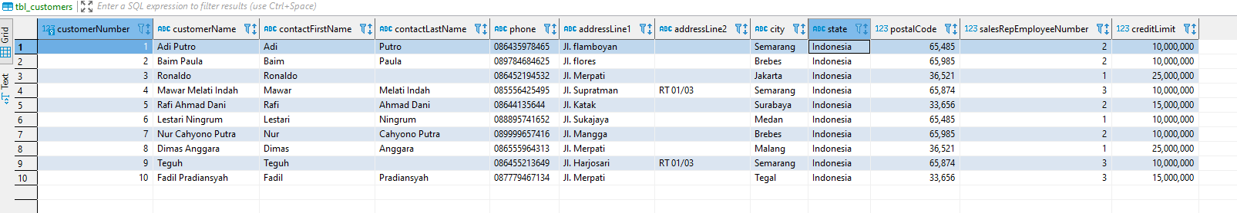

-------------------------------------------------------------------------------------------------------------

1. Products => stores daftar/list model product ( dalam hal ini bisa mobil/motor dll )

-------------------------------------------------------------------------------------------------------------

create table tbl_products(

    productCode varchar(50) primary key,

    productName varchar(50),

    productLine varchar(50),

    productScale int,

    productVendor varchar(50),

    productDescription text,

    quantityInStock int,

    buyPrice int,

    MSRP int,

);

INSERT into tbl_products values

('MBL002', 'Mobil', 'Transportasi', '300', 'Toyota', 'Produk mobil', '132', '300000000', '370000000'),

('MBL003', 'Mobil', 'Transportasi', '300', 'Honda', 'Produk mobil', '267', '300000000', '260000000'),

('MTR001', 'Motor', 'Transportasi', '100', 'Suzuki', 'Produk motor', '78', '10000000', '13000000'),

('RMH001', 'Rumah', 'Properti', '10', '99dev', 'Rumah kapling', '9', '300000000', '500000000'),

('RMH002', 'Rumah', 'Properti', '15', '99dev', 'Rumah elit', '25', '650000000', '1000000000');

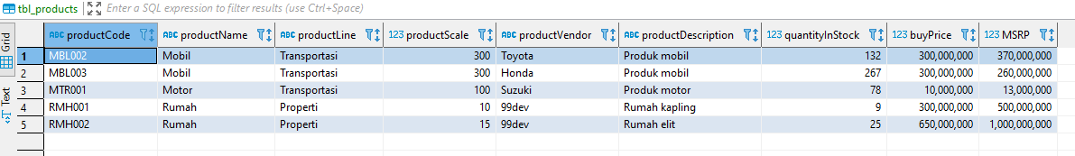

-------------------------------------------------------------------

1. Productlines => stores daftar/list kategori product

-------------------------------------------------------------------

create table tbl_productLines(

    productLine varchar(50) primary key,

    textDescription text,

    htmlDescription text,

    image varchar(255)

);

INSERT into tbl_productLines values

('Transportasi', 'ini penjulan transportasi', '', 'gambarmbl2'),

('Properti', 'ini penjulan properti', '', 'gmbrrumah');

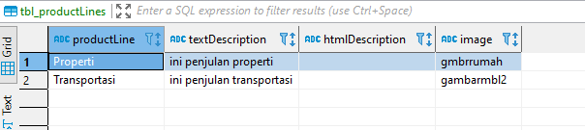

----------------------------------------------------------

1. Orders => store Order Sales oleh customer

----------------------------------------------------------

create table tbl_orders(

    orderNumber  int identity(1,1) primary key,

    orderDate datetime,

    requireDate datetime,

    shippedDate datetime,

    status varchar(15),

    comments varchar(100),

    customerNumber int

);

INSERT into tbl_orders(orderDate, requireDate, shippedDate, status, comments, customerNumber)values

('2020-10-15 13:25:55', '2020-10-15 17:22:12', '2020-10-15 13:25:55', 'Confirm', '', '2'),

('2020-10-15 13:11:43', '2020-10-15 17:00:55', '2020-10-15 13:27:55', 'Confirm', '', '5'),

('2020-10-15 13:25:55', '2020-10-15 13:25:55', '2020-10-15 13:25:55', 'Packing', '', '4'),

('2020-7-6 13:11:43', '2020-7-15 17:00:55', '2020-7-16 13:27:55', 'Confirm', 'warna hitam', '7'),

('2020-9-22 13:25:55', '2020-9-15 13:25:55', '2020-9-16 13:25:55', 'Packing', '', '1');

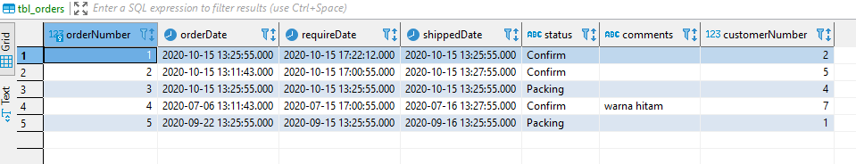

-------------------------------------------------------------------------------------

1. OrderDetails => store Item Order sales dalam setiap order sales

--------------------------------------------------------------------------------------

create table tbl_orderDetails(

    orderLineNumber int identity(1,1) primary key,

    orderNumber int unique,

    productCode varchar(50),

    quantityOrdered int,

    priceEach int,

);

insert into tbl_orderDetails(orderNumber, productCode, quantityOrdered, priceEach)values

('1', 'RMH001', '1', '500000000'),

('2', 'RMH001', '1', '500000000'),

('3', 'MBL001', '1', '450000000'),

('4', 'MBL002', '1', '370000000'),

('5', 'MTR001', '2', '250000000');

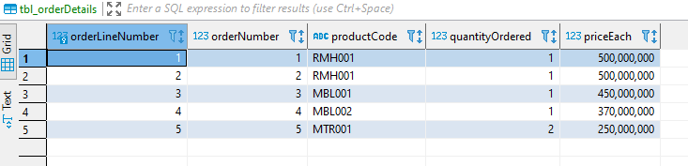

------------------------------------------------------------------------------------------------------------

1. Payments => store Pembayaran oleh customer sesuai dengan akun pembayaran

------------------------------------------------------------------------------------------------------------

create table tbl_payments(

    checkNumber int identity(1,1) primary key,

    customerNumber int,

    paymentDate datetime,

    amount int

);

INSERT into tbl_payments(customerNumber, paymentDate, amount)values

('5', '2020-10-15 13:30:33', '25000000'),

('2', '2020-10-15 13:25:55', '25000000'),

('4', '2020-10-15 13:25:55', '25000000'),

('1', '2020-9-22 13:25:55', '25000000'),

('7', '2020-7-6 13:11:43', '25000000');

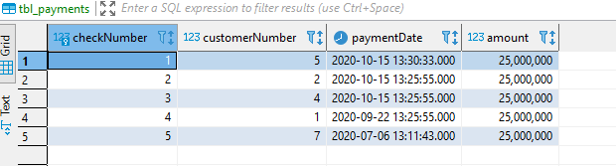

-----------------------------------------------------------------------------------------------

1. Employee => store informasi karyawan dalam sebuah organisasi struktur

------------------------------------------------------------------------------------------------

create table tbl_employee(

    employeeNumber int identity(1,1) primary key,

    firstName varchar(50),

    lastName varchar(50),

    extension char check(extension in('Y','N')),

    email varchar(50) unique,

    officeCode int,

    reportsTo int,

    jobTitlte varchar(50)

);

INSERT INTO tbl_employee(firstName, lastName, extension, email, officeCode, reportsTo, jobTitlte)values

('Indah', 'Sari', 'Y', 'indah@gmail.com', '3', '4', 'Staff'),

('Bayu', 'Riyadi', 'N', 'bayu@gmail.com', '3', '4', 'Staff'),

('Afis', 'Putra', 'Y', 'afis@gmail.com', '1', '5', 'Staff'),

('Resa', 'Kumala', 'Y', 'resa@gmail.com', '2', '6', 'SPV'),

('Fahmi', 'Afianto', 'Y', 'fahmi@gmail.com', '4', '6', 'SPV'),

('Yunanda', 'Gilang', 'Y', 'gilang@gmail.com', '1', '5', 'Manager');

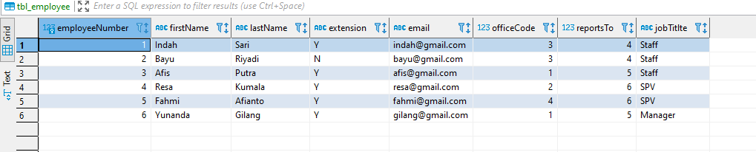

--------------------------------------------

1. Offices => store data sales office

--------------------------------------------

create table tbl_offices(

    officeCode int identity(1,1) primary key,

    city varchar(50),

    phone varchar(13) unique,

    addressLine1 varchar(100),

    addressLine2 varchar(100),

    state varchar(50),

    postalCode int,

    territory varchar(50)

);

INSERT into tbl_offices(city, phone, addressLine1, addressLine2, state, postalCode, territory)values

('Semarang', '021666', 'Jl. Pemuda', '', 'Indonesia', '66452', 'Indonesia' ),

('Semarang', '021645', 'Jl. Indraprasta', '', 'Indonesia', '65345', 'Indonesia' ),

('Tegal', '024689', 'Jl. batu', '', 'Indonesia', '55124', 'Indonesia' ),

('Pemalang', '056645', 'Jl. Damai', '', 'Indonesia', '11204', 'Indonesia' );

